Eleanor Moore
e.s.moore2@newcastle.ac.uk

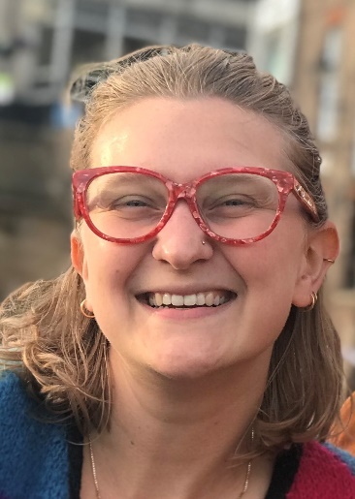
Why did you choose to study with the ONEPlanet DTP? What are you researching?

I first and foremost chose the ONEPlanet DTP for the project. I research the trade-offs and benefits across socio-ecological dimensions from tree planting in the Kilombero Valley, Tanzania. My project also has two case partners which will ensure my research has relevance to projects happening on the ground in the landscape which played a big role in my decision.

What do you think are the key benefits of your postgraduate study?

Working with case partners means my research will inform ongoing restoration projects in the Kilombero Valley. I also like the independence and flexibility that comes with postgraduate study. It is the first step into an academic career and you learn a lot more about how academia works and you get to learn from experts in your field and others.

How will your current research/study help you achieve your career ambitions?

I want to produce impact-driven research and a big part of that is working with institutions to define what you are doing and ensure it is relevant and can be applied in a practical way. My current research will help me learn how to do that.

What impact will your current research achieve?

Through working with IUCN and Reforest Africa, I will contribute to restoration planning of the Kilombero Valley. Specifically, informing how agroforestry can be used as a restoration tool for small-scale farmers.

What have you enjoyed most about being a student in Newcastle/Northumbria?

I have really enjoyed becoming part of the Modelling, Evidence and Policy research group and getting to know my supervisors and fellow PhD students (albeit virtually). Everyone is very welcoming and open so the atmosphere feels very supportive.

Can you recommend three ‘top tips’ (pieces of advice) to share with new students?

- The start of your PhD can be a bit confusing, so try to talk to other students as much as possible so you can help each other.
- Take it a couple of months at a time and define goals in incremental stages.
- Be honest and upfront with your supervisors, it is okay to say if you are finding something difficult.

What is your best memory of your time here so far?

I enjoyed doing the escape room for the online RAC and some of the zoom meetings with fellow PGR students in my research group.

Anything else you would like to tell us?

(For example, have you become a student ambassador, gained any work experience, joined any clubs, societies or teams, reached any personal goals, or have any other comments you’d like to make?)

I have started co-organizing the Ridley 2 seminar series at Newcastle which is a great experience to interact with people from a range of research areas and to learn more about how to engage others in science.

